BIG IDEA # 1 LEARNING STORY
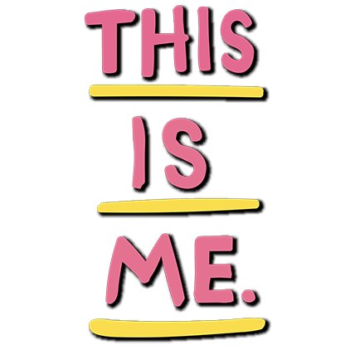

Interests

Challenges

Accomplishments

Passions

A quality learning story reveals who you are as a person through detailed examples or experiences. You can draw from your interests, accomplishments, passions, or even challenges.
- Your story should demonstrate how these experiences have shifted your thinking, broadened your perspective, and shaped who you are becoming. The process of crafting your story will be personal, and you may choose to include “aha!” moments, learning milestones, struggles, dilemmas, uncertainties, and breakthroughs..
- What is it that helped you become who you are? ie STUDENT ATHLETE, (play school and community sports), SHOP/trades (have my own car and work on it in the shop), CHEF/BAKER (love being creative in the kitchen), my friends and family (how?), ACADEMIA (work hard to get all A’s)

My focus area might be:_________________________

(fitness, academics, fine arts, visual arts, culinary, community service, business, social networking, trades, languages, leadership, etc…

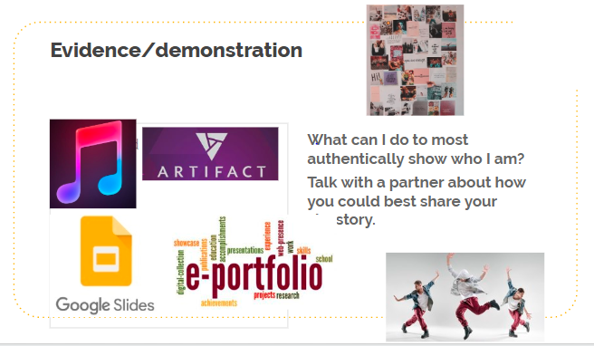

Big Idea: Showcase yourself
Brainstorm showcase ideas that you could do:

My Show case plan:
_______________________

